**Discounting in the Sales Process**

When a sales rep puts together a quote, it’s almost certain they will want to apply discounts to at least a few products. After all, they’re trying to negotiate a deal. Salesforce CPQ supports this kind of basic discounting, but it also does much more. For example, your business can reward customers who buy large quantities of items by giving them a volume-based discount to encourage bigger sales. Salesforce CPQ can apply volume-based discounts automatically so that sales reps don’t have to search through tables of out-of-date discounting data. CPQ also keeps track of different types of discounts, such as partner or distributor discounts, so that pricing details are never lost. Salesforce CPQ aims to make discounting easy by simplifying or automating the process.

The Price Waterfall

To keep track of adjustments to pricing and discounts, Salesforce CPQ uses multiple pricing fields on the quote line, each field representing specific changes. Some fields, such as List Price, represent adjustments but most fields are affected by some kind of discount.

| **Pricing Field** | **What It Represents** |
| --- | --- |
| Original Price | Price book price |
| List Price | Price book price, percent of total price, block price, or option price override |
| Special Price | Cost plus markup price, contracted price, or option discount |
| Regular Price | Result of volume-based discounts |
| Customer Price | Result of manually editable discounts |
| Partner Price | Result of partner discount, set manually or through automation |
| Net Price | Result of distributor discount, set manually or through automation |

This list of prices is often referred to as the price waterfall because each price cascades down to affect the next price. For example, CPQ takes the special price and deducts the volume-based discounts to calculate the regular price. Then, it takes regular price and deducts manual discounts to calculate customer price, and so on.

It’s good to be familiar with the price waterfall so that you can understand how CPQ eventually calculates the net price. This is what we actually ask the customer to pay for a given product, and it is synchronized to the opportunity product price.

 bundles are collections of products sold together as a set. They’re a great way to help sales reps remember what’s supposed to be sold together and what products are available for upsells.

Have you ever come across a great deal on a bundle? Maybe it’s all three movies in your favorite sci-fi trilogy sold for one low price. Or maybe it’s a discount on the latest cell phone when packaged with a year of service. To encourage customers to buy bundles, businesses often discount the bundled products while leaving the unbundled products full price. Salesforce CPQ supports exactly this scenario, making it easy for administrators to set up bundle-based discounts.

Option Discounts and Other Pricing Methods

 the series of price fields CPQ uses to track quote line pricing. One field, Special Price, is used to represent option discounts. However, CPQ also uses the Special Price field to represent the outcome of cost plus markup and contracted pricing adjustments. So what happens if option discounts are used with one of the other pricing methods?

Only one adjustment can be used for the Special Price field, so Salesforce CPQ prioritizes them. Cost Plus Markup has the highest priority. If that’s not used, then Contracted Pricing is applied. Lastly, if no other adjustments exist, the Option discount is applied to the List Price.

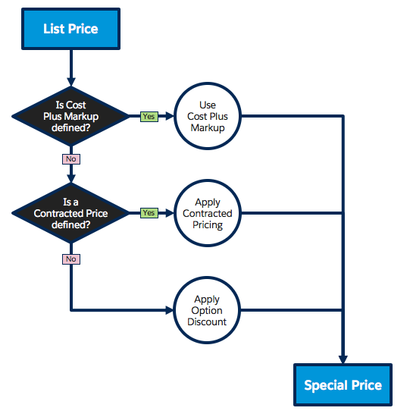

Option discounting is an easy way to automatically discount products sold as part of a bundle. Another way to automate discounts is to use a tool called Discount Schedules, which lets admins set up volume-based pricing. In the next unit we see how to use Discount Schedules to reward customers who buy in bulk.

## Pump Up the Volume

Buying in bulk is a good way to save money if you’re OK with buying a lot of something at one time. Why get a single roll of paper towels when you can get 40 at a nice discount? Businesses offer these quantity-based discounts to encourage larger deals, but it can be a challenge for sales reps to keep track of how much they should discount for given quantities. Salesforce CPQ can automatically apply the right volume-based discount for each specific deal by using a tool called Discount Schedules. You can think of a discount schedule as a table of quantities and percentages.

| **Lower Quantity** | **Upper Quantity (up to but not including)** | **Percent** |
| --- | --- | --- |
| 30 | 60 | 10% |
| 60 | 90 | 20% |
| 90 | Unlimited | 30% |

In this example there is no discount for buying 29 of an item, but 30 qualify for the 10% discount, and 60 qualify for 20% off. **There is no upper bound for the 90+ range because we want to give a 30% discount for any number of units above 90, whether it’s 100 or 1,000.**

Notice that the discount schedule uses 60 for both the upper quantity of the first tier and the lower quantity of the second. This can seem odd, but it makes sure there are no gaps for fractional quantities to fall through. If the upper quantity of the first tier was 59, then 59.5 would fall through the cracks and no discount would be applied. So, with discount schedules it’s understood that the upper quantity of a tier is NOT included, which is why buying 60 units qualifies for a 20% discount.

There are even more objects that have Discount Schedule lookups, allowing administrators to apply volume-based pricing in very targeted ways.

| **Object** | **Volume Discount Scenario** | **Priority** |
| --- | --- | --- |
| Contracted Price | Discounts only for a specific account. | 1 |
| Price Dimension | Discounts for one-time fees attached to subscription products or segments of the subscription term. | 2 |
| Product Option | Discounts only when a product is sold in a bundle. | 3 |
| Feature | Discounts for every product in a bundle feature. | 4 |
| Product | Discounts whenever a product is added to the quote. | 5 |

Since discount schedules can be applied in so many different places, there are times when there can be a quote line that qualifies for two or more discount schedules.

## Limiting Discount Schedules By Price Book

Sometimes businesses use different price books to control pricing for certain types of customers. For example, they can have a price book specifically for academic institutions. By default, discount schedules apply to all quotes, regardless of which price book is used. However, it is possible to identify price books that should not use a given Discount Schedule. Here’s how.

Find the Excluded Pricebook IDs field on the Discount Schedule record. Now, paste in the Salesforce ID of the price book that shouldn’t use the discount schedule. From now on, quotes including that price book will stop using it.

If you have multiple price books that shouldn’t use the discount schedule, add them to Excluded Pricebook IDs in a comma-separated list.

There’s one last way to limit when a discount schedule is applied—by using the Product and Price Book fields together on the Discount Schedule record. These two lookup fields are always used together and cause the discount schedule to apply only when the specified product is added to a quote that uses the specified price book. Note that these fields are rarely used because they’re so limiting, but they can be helpful in fringe use cases.

Additionally, be aware that a discount schedule set up this way overrides the Discount Schedule lookup field on the Product record. That said, it still has the lowest priority when compared to other places discount schedules can be applied. For example, a discount schedule used for a contracted price still takes priority over a product and price book-specific schedule.

Now you know how to create discount schedules and where to use them. Next, we look at how to adjust the way discount schedules count quantities when determining which discount tier to use.

**Aggregation Scope**

One of the most important discount schedule settings is the Aggregation Scope field. This tells CPQ how to handle multiple quote lines that share the same discount schedule. There are three possible choices for Aggregation Scope. To illustrate how each affects pricing, let’s consider the quote from the screenshot below.

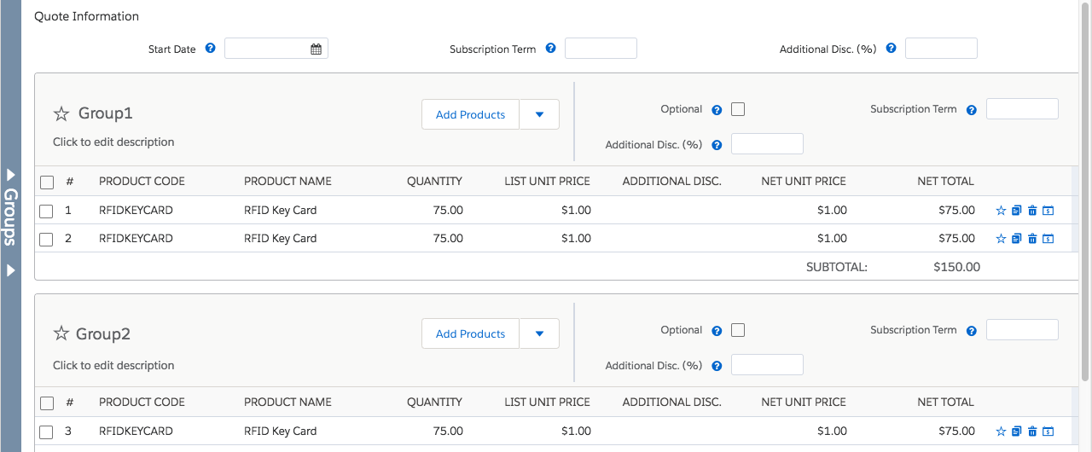

* **None**: This setting is the default value, and causes CPQ to treat each quote line independently; no aggregation is performed. In the quote above, no discount would apply to any of the quote lines!
* **Quote**: This setting counts the quantities of every quote line across the entire quote. For example, in the quote above, CPQ would add all three lines together for a total of 225, so the customer would get the second tier discount of 20%.
* **Group**: This setting counts quantities of quote lines that are in the same quote line group. The quote lines in the first group would be added together for 150 total, qualifying for the first tier discount of 10%. The quote line in the second group would not be counted toward a discount.

It’s worth noting that quote lines flagged as optional are never counted in the aggregated quantity. Optional items are meant to show customers what is possible, not what they actually get.

## Aggregation Scope with Bundles

While it’s usually easy to see how the Aggregation Scope field determines which quantity to use with discount schedules, there’s one instance that’s counterintuitive. Imagine that the Bulk Keys discount schedule is applied to the bundle option for the RFID key card, but NOT applied to the RFID key card product record. Then, the sales rep sells the Security Console bundle with key cards, and also adds extra key cards as a separate line, as seen below.

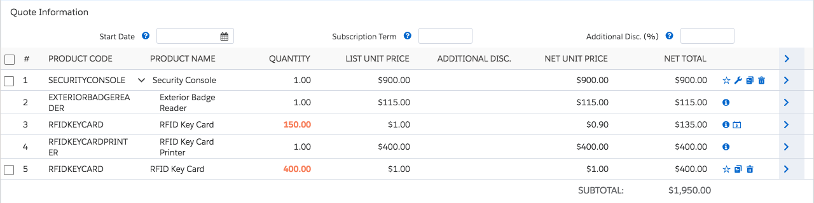

Even if the aggregation scope of the discount schedule is set to Quote, only the quantity of the bundled key cards is counted. Therefore the bundled quote line only qualifies for the 100–200 tier discount, ignoring the 400 extra key cards. Because the two quote lines do not share the same discount schedule, the stand-alone key cards aren’t included in the aggregation. If you want the stand-alone key cards to aggregate with the bundled key cards, you must add the Bulk Keys discount schedule to the product record of the RFID Key Card.

There’s one last consideration when using discount schedules with bundles. Some bundled products are included free of charge due to the Bundled checkbox on the product option. By default, the quantities of these free products are not included in discount schedule calculations. If you need them to count toward a discount, check the Include Bundled Quantities checkbox on the Discount Schedule record.

## Cross Products Aggregation

Along with RFID Key Cards, AW Computing also sells RFID Key Fobs that work with the same security system. They want customers to get the same volume discount on key fobs as they do key cards, so they reuse the Bulk Keys discount schedule on the Key Fob product record. This seems to work well until a sales rep realizes that when both products are sold on the same quote, the quantities are considered independently. They ask their CPQ admin if the volume discount can be applied to the total amount of cards and fobs combined—this is called cross product aggregation.

Thankfully, it’s easy for admins to have Salesforce CPQ aggregate quantities of different products, as long as they share the same discount schedule. Just check the field named Cross Products on the Discount Schedule record. Then, when a sales rep sells 75 key cards and 25 key fobs, both quote lines are discounted at 10%.

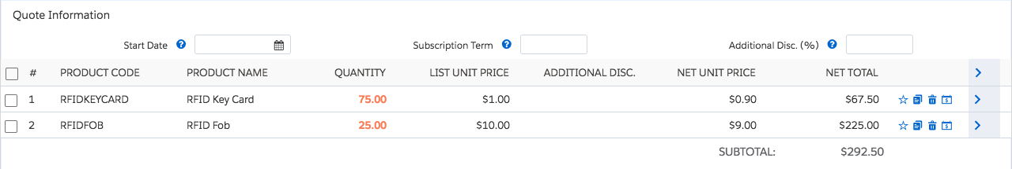

Note

#### Note

Cross Products only works if the Aggregation Scope field is set to either Quote or Group.

## Cross Order Aggregation

Imagine that last time you closed a RFID Key Card deal, the customer bought 80 RFID Key Cards, which wasn’t quite enough for a volume discount. Then, this week, the customer comes back to buy 50 more key cards. Remember, they’ve now bought 130 total, which would qualify for a discount if they’d been purchased at the same time. By default, CPQ treats each quote independently. However, your discount schedule can be configured to count the amount of products sold in previous sales. All you have to do is check the Cross Orders field on the Discount Schedule record.

CPQ knows what the customer has purchased in the past by looking to asset records associated with the customer’s Account. Asset records are created automatically during the CPQ contracting process, so the information is there when needed.

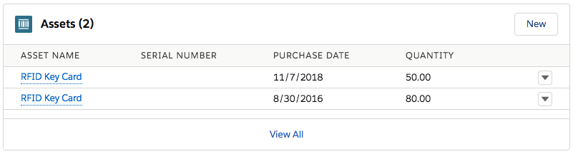

Note that Cross Orders only affects the price of the key cards on the current quote. It doesn’t retroactively discount previous sales, nor does it discount the current sale to make up for what the customer would’ve saved if they had bought everything at once.

Be aware that Cross Orders uses all assets records a customer has when aggregating the total quantity to use for the discount schedule. This includes assets that were bought years ago! It’s possible to limit which assets are included in Cross Orders, but it takes some adjusting. We look at how to handle this situation in the next unit.

## Introduction

As you saw in the last unit, Salesforce CPQ can aggregate quantities from multiple records across orders to determine the right discount tier to use for a discount schedule. However, there are times when we don’t want every single record to count toward the total quantity. For example, a cross order schedule tells CPQ to aggregate every asset that exists on the account, but AW Computing wants only those assets purchased in the last 365 days to count. With a little work it is possible to filter which asset records are included in the aggregated sum.

## Distinguish Old and New Assets

The first step in filtering records is to distinguish which assets have been purchased in the last 365 days. In this example, AW Computing has diligently maintained an asset field named Purchase Date over the years. You use this information to create a custom formula checkbox field named Purchased This Year, which returns “True” when the Purchase Date is less than 365 days from today’s date.

## Quote Line Quantity Field

By default, Salesforce CPQ uses the Quantity field on the quote line to determine which discount tier to use. This works well in most cases, but there are times when you don’t actually want to use the quote line quantity.

Imagine this scenario: AW Computing wants to give a discount on RFID Key Cards, but it wants to base the discount on how many door locks are sold, **not** how many key cards are sold. For example, if the customer buys more than 30 door locks, they get a 5% discount on key cards. In this case, the quantity of key cards is irrelevant.

Salesforce CPQ supports this scenario with just a little setup.

* First, you create a custom numeric field on the Quote Line object. You can call it Total_Locks__c.
* Second, you update the value of Total_Locks__c for every RFID Key Card quote line record. (A price rule works nicely here, but that is beyond the scope of this module).
* Third, you update the Bulk Keys Discount Schedule to choose Total_Locks__c for the Quote Line Quantity Field picklist (after adding Total_Locks__c as a picklist value).  
  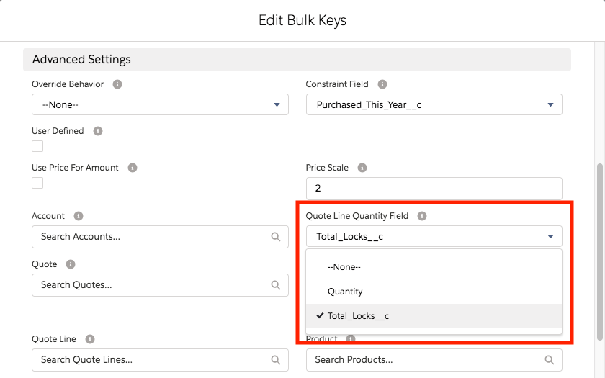

Note

#### Note

Discount schedules using the Quote Line Quantity field do not support cross order functionality to aggregate quantities from asset records.

While it takes some work to set up the Quote Line Quantity Field field, the effort allows you to support special cases where the Quantity field isn’t the right fit. Now that we have explored how to control what quantities are included in discount schedules, let’s look at some advanced ways to effect volume-based pricing.

## Percent vs Amount Discount Schedules

Discount schedules are most often configured to reduce a price by a percentage, making them reusable on many products regardless of the product’s price. In other words, a 10% discount works just as well on a $1.00 key card as it does on a $2,000.00 copy machine. However, some businesses need to discount by a defined amount instead of a percentage. For example, AW Computing can discount copy paper by $5.00 per unit for quantities greater than 50. In this scenario, the discount is always $5.00 even if the price of paper changes from $85.00 to $87.00.

To use a fixed amount instead of a percentage for a discount schedule, set the Discount Unit field to Amount.

When the discount unit is set to amount, the discount tier editor shows a Discount ($) field instead of a Discount (%) field

The field named Override Behavior, found on the Discount Schedule record, controls if sales reps can modify discount tiers. It has has three choices.

* **--None--**: This makes all values fixed and noneditable by the sales rep.
* **All**: This lets the sales rep change the upper and lower bounds, as well as the percent or amount for each discount tier. Sales reps have complete control over the discount schedule.
* **Current Tier Only**: This lets the sales rep change the percent or amount for the Discount Tier based on the current quantity. Although the lower and upper bounds are editable in the user interface, they don’t affect the calculation.

Since editing discount schedules gives sales reps a lot of control over pricing without touching the Additional Discount field, it’s a good idea to create a validation rule or approval process triggered whenever a discount schedule is overridden. Sales reps should also be trained how to add discount tiers properly. If the lower bound of a tier is not equal to the upper bound of the next tier, an error message appears.

## Range vs Slab Discount Schedules

When you created the Bulk Keys discount schedule (as shown in the table below) you found that adding 250 key cards to the quote resulted in a price of $0.80 per card, for $200.00 total. In other words, the top tier 20% discount applied to all 250 cards. That’s because the Discount Schedule Type field is set to Range, the default and most common choice.

| **Tier Name** | **Lower Bound** | **Upper Bound** | **Percent** |
| --- | --- | --- | --- |
| First Level | 100 | 200 | 10% |
| Second Level | 200 |  | 20% |

Setting the Discount Schedule Type to “Slab” results in a very different calculation for the price of the 250 key cards. Instead of applying a single discount percent to all units, the 250 cards are divided into three slabs: 100, 100, and 50. The first slab has no tier defined, so gets no discount. The second slab is for those cards that fall in the First Level tier, so they get 10% off. The last 50 cards are in the Second Level tier, so they get 20% off.

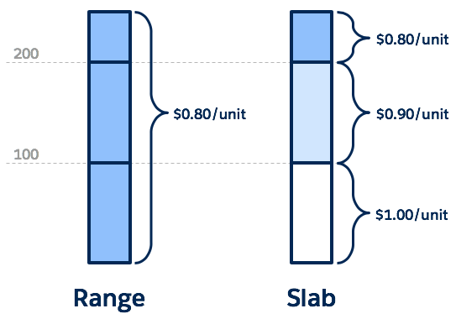

The overall price of the key cards when using Slab is calculated like so:

(100 * $1.00) + (100 * $0.90) + (50 * $0.80)

Doing the math gives us $230.00, more than the $200.00 we got by using the Range type.

Slab discount schedules are perfect for when you need different price-per units for each tier. For example, imagine a “first two free, all others full price” scenario. To set up this discount schedule, you create one tier that’s discounted at 100%, as seen below.

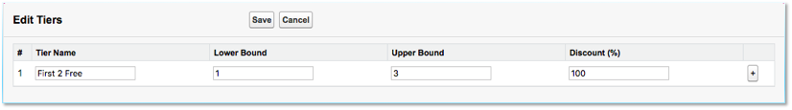

When using Slab with this discount tier, if the customer buys five units, the first two are free and the last three aren’t discounted. If we used the Range type, then no units are discounted because there is no tier for five units. This is just one example of many clever ways to leverage Slab discount schedules.